SQL 2016

# Installation Settings

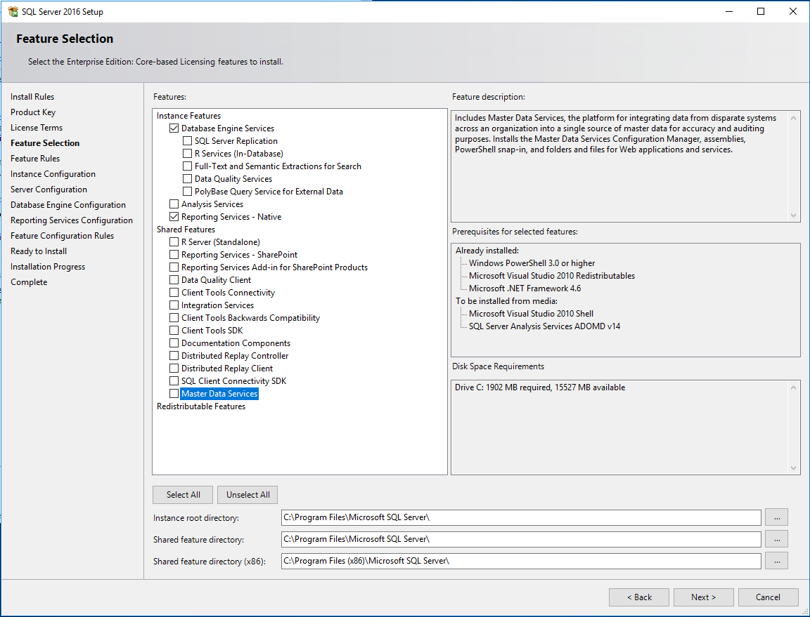

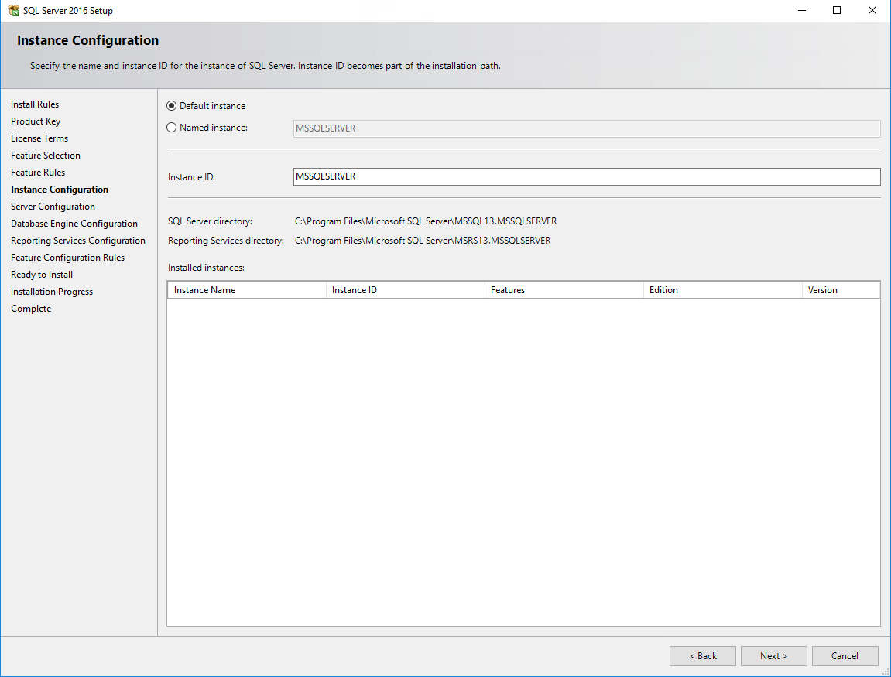

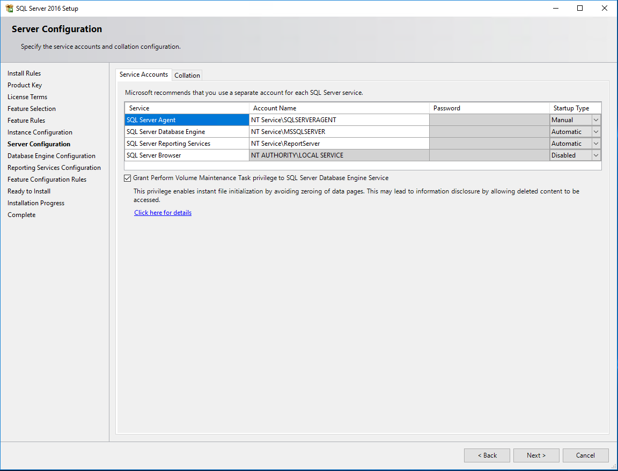

#mp!r3#13ct0n1cs~2016

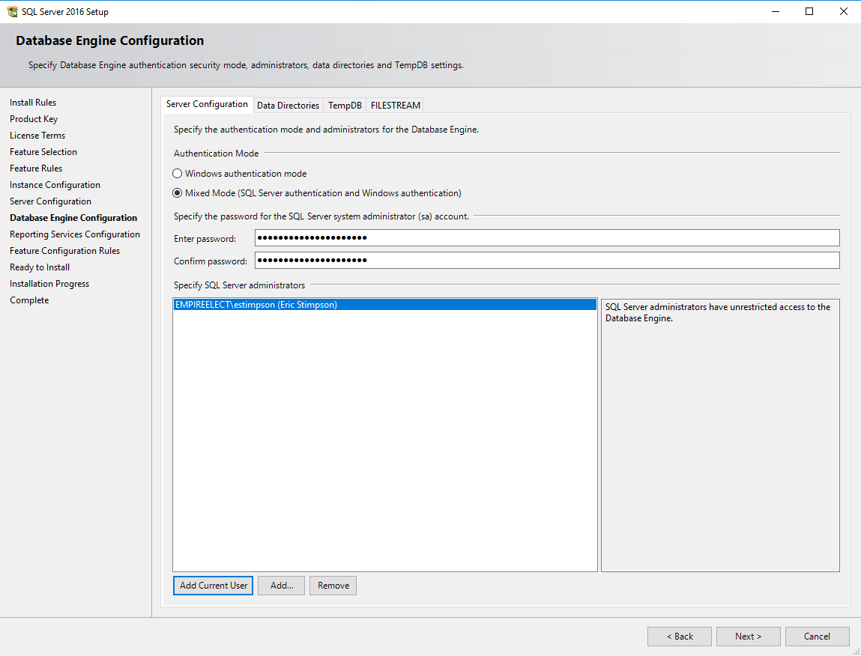

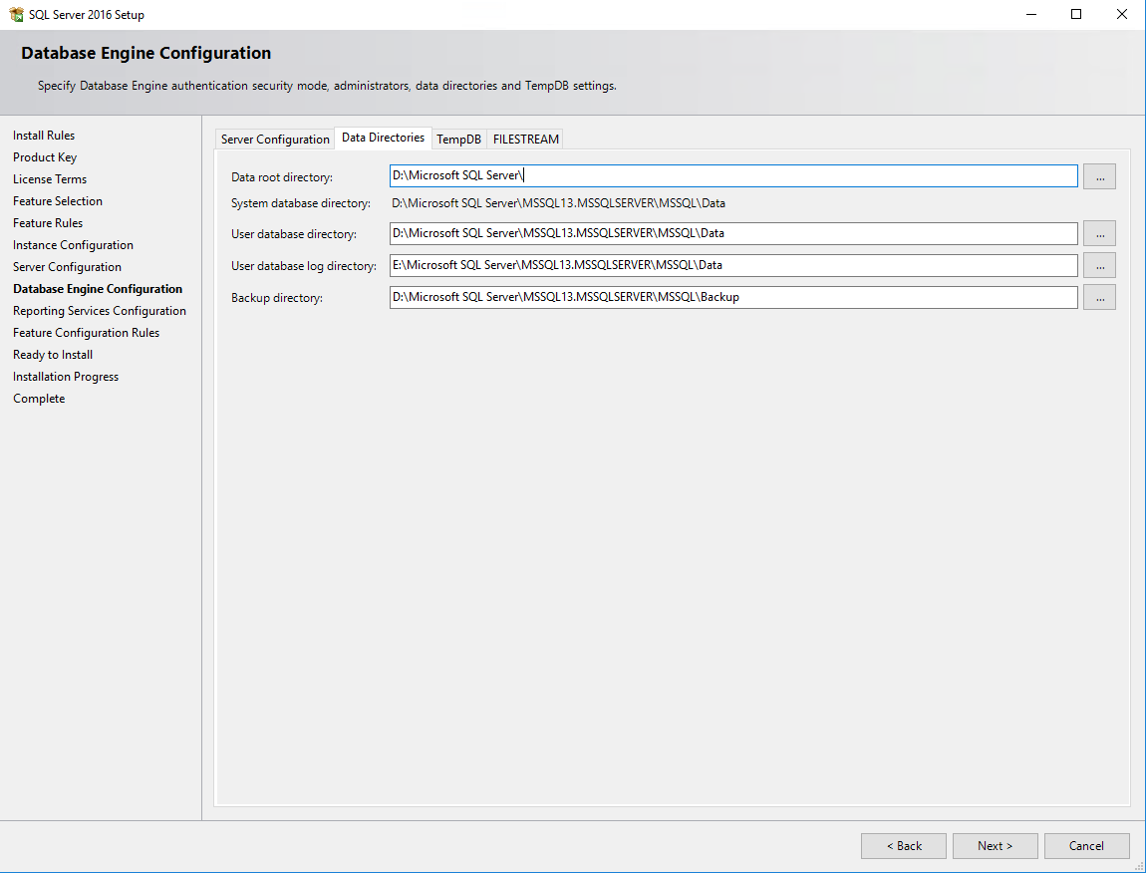

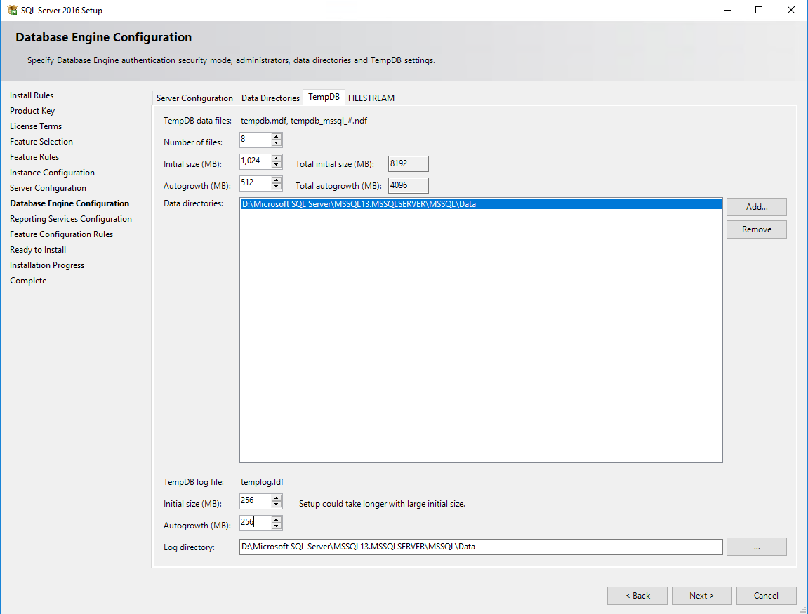

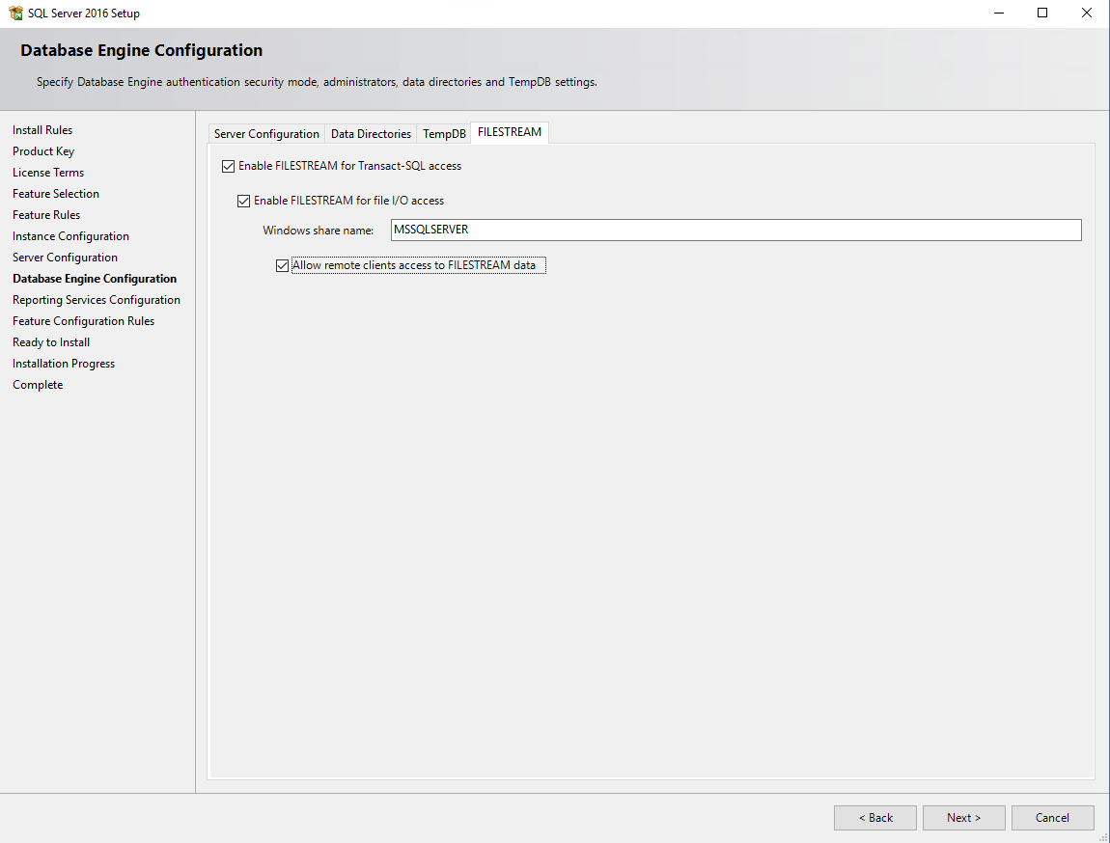

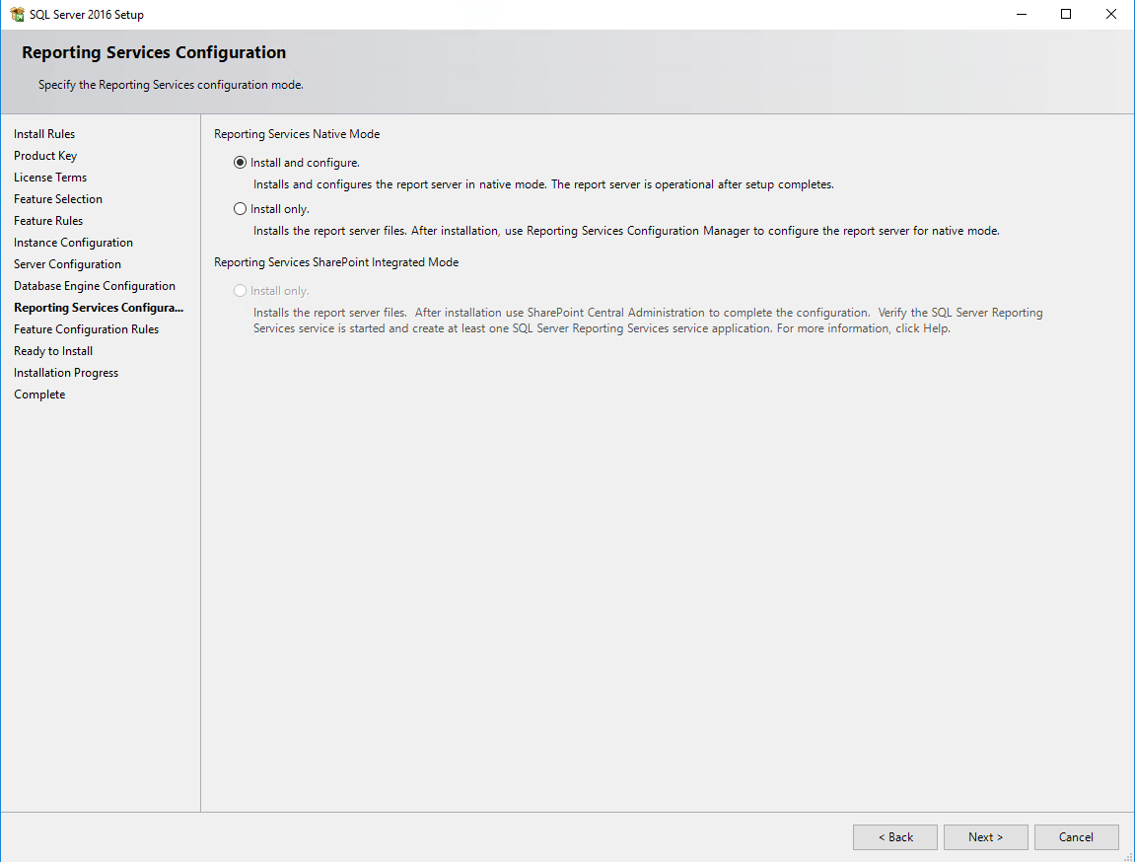

# Open Items

1. Security
2. DB Mail
   1. ~~Setup profile (DBMAIL)~~
   2. ~~Make all calls to generate mail use DBMAIL profile~~
3. Jobs
   1. ~~Custom - Update label format information HND-Troy~~
      1. ~~Requires EEH linked server~~
   2. DB Maint – sp_BlitzFirst
      1. Drop PerfDB.dbo.BlitzCache.
   3. ~~Historical – CopyDataDaily~~
      1. ~~Requires EEH linked server~~
      2. ~~Procedure acctg_inv_sp_exceptions_daily should reference HistoricalData.dbo.acctg_inv_exceptions_daily.~~
   4. Enable agent, auto-restart, ~~history~~
4. ~~sp_FTWho~~
5. Backup / Recovery Plan
   1. Setup
   2. Testing
6. ~~Linked servers (to/from EEH)~~
   1. ~~Unable to connect to EEH from EEI-SQLPWV03~~
   2. ~~Unable to connect from EEH to EEI-SQLPWV03~~
7. Queries that reference linked server between EEISQL1 and EEISQL2 (or SRVSQL1, SRVSQL2).
8. Testing:
   1. ODBC
   2. Shipping
   3. Order Entry
9. Compare DatabaseBackup to procedures usp_FullBackups and usp_DiffLogBackups
10. Compare CommandExecute to USP_Calls logging.

# GO LIVE

1. Restore all DBs
2. Reload 2016 stored procedures
3. DNS
4. ODBC
5. Turn on Jobs
6. Copy FTP Commands